Guide for Authors - 2024

Manuscripts should be submitted as single Microsoft Word 2003 files.
Preferred font 12 pt Times New Roman (please, do not use any other fonts, except for Symbol), 1.5 spaced lines, 1.25 cm first-line indent. Decimal values (e.g. 0.1; 0.9; 2.3) should be written using a decimal point.

Review/ Research article/Short communication
https://doi.org/10.17308/kcmf.2024.26/000

Modelling of interdiffusion and phase formation in thin-film two-layer systems of polycrystalline oxides of titanium and cobalt
(All proper nouns should be capitalized; titles and subtitles should be left-aligned)
N. N. Afonin¹, V.A. Logacheva²

¹Voronezh State Pedagogical University,
86 ul. Lenina, Voronezh 394043, Russian Federation
(Official name and address of the organisation)
²Voronezh State University,
1 Universitetskaya pl., Voronezh 394018, Russian Federation

Abstract
The abstract should be 200-250 words and include the following sections.

Purpose: States the problem considered in the article, its importance, and the purpose of the research.
Experimental: Provides information about the objects being studied and the methods used.
Conclusions: Provides a brief description of the principal results, major conclusions, and their scientific and practical relevance.
Keywords: Please, provide 5-10 keywords for the principal concepts, results, and terms used in the article.
Funding: This work was funded by RFBR according to the research project No. 18–29–24128.
Acknowledgments: The DTATGA, XRD and SEM studies were performed on the equipment of the Engineering Center of Saint Petersburg State Institute of Technology.
For citation: Afonin N. N., Logacheva V. A. Modelling of interdiffusion and phase formation in the thin-film two-layer system of polycrystalline oxides of titanium and cobalt. Condensed Matter and Interphases. 2024;26(1): 000-000. https://doi.org/10.17308/kcmf.2024.26/000

____________
Nikolay N. Afonin, nafonin@vspu.ac
© Afonin N. N., Logacheva V. A., 2024
The content is available under the Creative Commons Attribution 4.0 License.

Article structure
The main text of the manuscript should have the following structure.

- Introduction
The introduction (1–2 pages) states the problem under consideration, its relevance, and the most important tasks that need to be resolved. Describe the scientific problems which have not yet been solved and which you sought to solve in your research. The introduction should contain a short critical review of previously published works in this field and their comparative analysis. It is recommended that the analysis is based on 20-30 studies (no more than 20% of references to the author’s own works, at least 50% of the references should be to articles published within the previous 5 years). The purpose of the article is indicated by the problem statement.
The Vancouver reference style is used in the journal: bibliographic references in the text of the article are indicated by numbers in square brackets; in the references section, the references are numbered in the order they are mentioned in the text.

Example of references in-text citations:
Single crystals of difluorides of alkaline earth elements are widely used as photonics materials [1-3] as well as matrices for doping with rare-earth ions [4,10].

References should primarily be made to original articles published in scientific journals indexed by global citation databases. References should indicate the names of all authors, the title of the article, the name of the journal, year of publication, volume (issue), number, pages, and DOI (Digital Object Identifier https://search.crossref.org/). If a DOI is lacking, a link to the online source of the article must be indicated. References to dissertation abstracts are acceptable if the texts are available online. It is vital that our readers can find any of the articles or other sources listed in the reference section as fast as possible. Links to unpublished literature sources or sources not available online are unacceptable.

- Experimental

The experimental section (2-3 pages) provides the details of the experiment, the methods, and the equipment used. The object of the study and the stages of the experiment are described in detail and the choice of research methods is explained.

- Results and discussion

Results and discussion (6-8 pages) should be brief, but detailed enough for the readers to assess the conclusions made. It should also explain the choice of the data being analysed. Measurement units on graphs and diagrams should be separated with a coma. Formulae should be typed using Microsoft Office Equation 3 or Math Type and aligned on the left side. Latin letters should be in italics. Do not use italics for Greek letters, numbers, chemical symbols, and similarity criteria.
All subheadings should be in italics.

Example:
  - X-ray diffraction analysis

Example of figure captions in the text of the article: Fig. 1, curve 1, Fig. 2b.

A complete list of figures should be provided at the end of the paper after the information about the authors.
Figures and tables should not be included in the text of the article. They should be placed on a separate page. Figures should also be submitted as separate *tif, *jpg, *cdr, or *ai. files. All figures should have a minimum resolution of 300 dpi. Name each figure file with the name of the first author and the number of the figure.

- Conclusions

Conclusions (1 paragraph) should briefly state the main conclusions of the research. Do not repeat the text of the article. The obtained results are to be considered with respect to the purpose of the research. This section includes the conclusions, a summary of the results, and recommendations. It states the practical value of the research and outlines further research problems in the corresponding field.

Contribution of the authors
At the end of the Conclusions the authors should include notes that explain the actual contribution of each co-author to the work.
Example 1:
Nikolay N. Afonin – Scientific management, Research concept, Methodology development, Writing – original draft, Final conclusions.
Vera A. Logachova – Investigation, Writing – review & editing.
Example 2:
The authors contributed equally to this article.

Conflict of interests

The authors declare that they have no known competing financial interests or personal relationships that could have influenced the work reported in this paper.

References
(The references are to be formatted according to the Vancouver Style. The reference list should only include articles published in peer-reviewed journals)

Examples:
Journal article
- Bahadur A., Hussain W., Iqbal S., Ullah F., Shoaib M., Liu G., Feng K. A morphology controlled surface sulfurized CoMn₂O₄ microspike electroncatalyst for water splitting with excellent OER rate for binder-free electrocatalytic oxygen evolution. Journal of Materials Chemistry A. 2021;20(9): 12255–12264. https://doi.org/10.1039/D0TA09430G
- Alexandrov A. A., Mayakova M. N., Voronov V. V., Pominova D. V., Kuznetsov S. V., Baranchikov A. E., Ivanov V. K., Fedorov P. P. Synthesis upconversion luminophores based on calcium fluoride. Condensed Matter and Interphases. 2020;22(1): 3–10. https://doi.org/10.17308/kcmf.2020.22/2524
- Kopeychenko E. I., Mittova I. Y., Perov N. S., Alekhina Y. A., Nguyen A. T., Mittova V. O., Pham V. Synthesis, composition and magnetic properties of cadmium-doped lanthanum ferrite nanopowders. Inorganic Materials. 2021;57(4): 367–371. https://doi.org/10.1134/S0020168521040075
Book: print
- Nakamoto K. Infrared and Raman spectra of inorganic and coordination compounds. New York: John Wiley; 1986. 479 p.
- Fedorov P. P., Osiko V. V. Crystal growth of fluorides. In: Bulk Crystal Growth of Electronic. Optical and Optoelectronic Materials. P. Capper (ed.). Wiley Series in Materials for Electronic and Optoelectronic Applications. John Wiley & Son. Ltd.; 2005. pp. 339-356. https://doi.org/10.1002/9780470012086.ch11
- Nanostructured oxide materials in modern micro-, nano- and optoelectronics. V. A. Moshnikov, O. A. Aleksandrova (eds.). Saint Petersburg: Izd-vo SPbGETU “LETI” Publ., 2017. 266 p. (in Russ.)
Conference proceeding: individual paper
- Afonin N. N., Logacheva V. A., Khoviv A. M. Synthesis and properties of functional nanocrystalline thin-film systems based on complex iron and titanium oxides. In: Amorphous and microcrystalline semiconductors: Proc. 9th Int. Conf., 7–10 July 2014. St. Petersburg: Polytechnic University Publ.; 2014. p. 356–357. (In Russ.)
Website
- NIST Standard Reference Database 71. NIST Electron Inelastic-Mean-Free-Path Database: Version 1.2. Available at: www.nist.gov/srd/nist-standard-reference-database-71
Patent
- Chekanov V. V., Kandaurova N. V., Rakhmanina Yu. A., Chekanov V. S. Ultrasound indicator 2. Patent RF, no. 2446384, 2012. Publ. 27.03.2012, bull. no. 9. (In Russ.)

Information about the authors

This section should include the full last and first name(s) of the author(s), their academic degree, academic title, affiliation, position, city, country. ORCID (register for an ORCID here https://orcid.org/register ) and e-mail.

Nikolay N. Afonin, Dr. Sci. (Chem.), Research Fellow, Professor at the Department of Science and Technology Studies, Voronezh State Pedagogical University (Voronezh, Russian Federation).
https://orcid.org/0000-0002-9163-744X
nafonin@vspu.ac.ru

Vera A. Logachova, Cand. Sci. (Chem.), Research Fellow at the Department of General and Inorganic Chemistry, Voronezh State University (Voronezh, Russian Federation).
https://orcid.org/0000-0002-2296-8069
kcmf@main.vsu.ru

Tien Dai Nguyen, PhD in Advanced Materials Science and Engineering, Lecturer/ Research at Institute of Theoretical and Applied Research (ITAR), Duy Tan University (DTU), Hanoi, Vietnam.
https://orcid.org/0000-0002-9420-210X
nguyentiendai@duytan.edu.vn

Valery V. Voronov, Cand. Sci. (Phys.–Math.), Head of the Laboratory, Prokhorov General Physics Institute of the Russian Academy of Science (Moscow, Russian Federation).
https://orcid.org/0000-0001-5029-8560
voronov@lst.gpi.ru

Received __.__.2024; approved after reviewing __.__.2024; accepted for publication __.__.2024; published online __.__.2024.

A complete list of figures should be provided at the end of the paper after the information about the authors.

Example:
Fig. 1. Dependences of the parameters a and c of the tetragonal lattice of nanocrystalline PdO films on the oxidation temperature T_{ox}: 1 − single-phase PdO films, 2 − heterophase PdO + Pd films; 3 − data of the ASTM standard [22,23]
Table 1. The values of relative electronegativity (ENE) of some chemical elements [30] and the proportion of the ionic component of the chemical bond in binary compounds of the AB composition formed by these elements

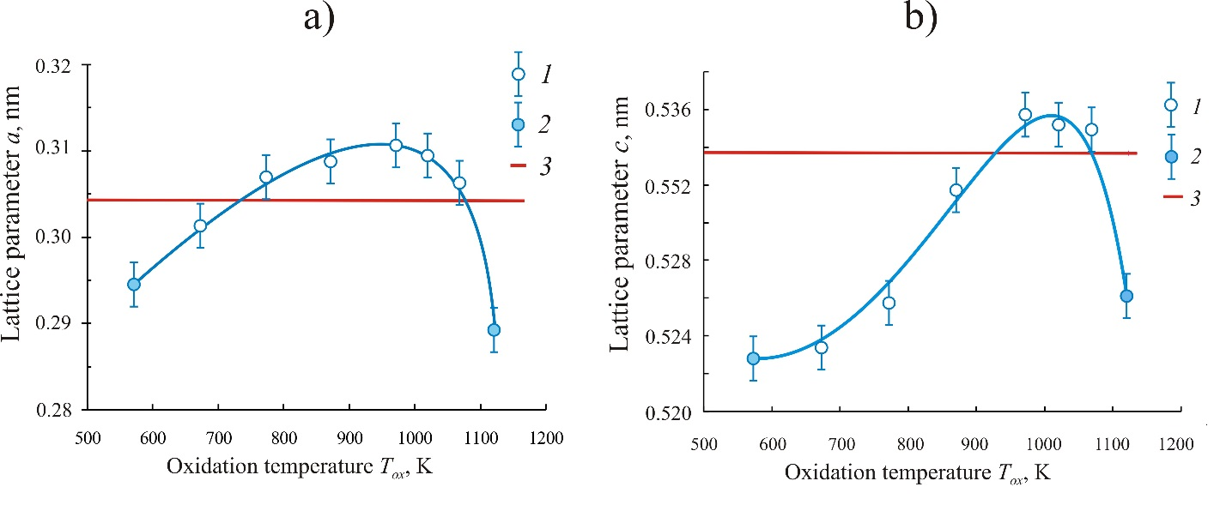
Fig. 1. Dependences of the parameters a and c of the tetragonal lattice of nanocrystalline PdO films on the oxidation temperature T_{ox}: 1 − single-phase PdO films; 2 − heterophase PdO + Pd films; 3 − data of the ASTM standard [22,23]

Table 1. Values of the ionic radii of palladium Pd²⁺ and oxygen O²⁻ [30 − 32]
Ion | Coordination number CN | Coordination polyhedron | Values of ionic radii R_{ion}, nm
Pd²⁺ | 4 | Square (rectangular) | 0.078 [30]; 0.086 [31]; 0.078 [32]
O²⁻ | 4 | Tetragonal tetrahedron | 0.132 [30]; 0.140 [31]; 0.124* [31]; 0.132 [32]

*The values of ionic radius were obtained on the basis of quantum mechanical calculations.

Accompanying documents
(The following documents should be submitted as PDF files)
1. Covering letter (with authorisation for open access publication)
2. License agreement (signed by all authors) https://journals.vsu.ru/kcmf/Licensingcontract
3. Manuscript.

EDITING AND PROOFREADING
When the layout is ready it is sent back to the authors for proofreading. The article should be sent back to the publisher within a maximum of three days. The authors may only correct printing mistakes.

