UDC 517.97: 532.526

**NAME OF THE MANUSCRIPT**

Name of the header (up to 50 characters, ellipses are acceptable)

**A. A. Antonov*, I. I. Ivanov*, P. P. Petrov\*\***

*\*Affiliation of the first and second author*

*\*\*Affiliation of the third author*

**Received __.__.20__**

**Abstract.** The abstract (200-250 words) presents a short summary of the manuscripts, underlining its importance and novelty, and describing the obtained results and their value. Formulas and special symbols are also not recommended.

**Keywords:** words or phrases (up to 10) that most appropriately reflect the content of the paper; lower case, separated with commas.

**INTRODUCTION**

This document is a template you can use when formatting you manuscript for the journal “Proceedings of Voronezh State University. Series: Systems Analysis and Information Technologies”. The manuscript should be structured as follows:

Abstract

Keywords

Introduction

Purpose of the study

Materials and Methods

Results and discussion

Conclusions

Acknowledgements (if necessary)

References

Information about the authors

The following information should be provided both in Russian and in English:

Name of the manuscript

Name(s) of the author(s)

Affiliation

Abstract

Keywords

Information about the authors

The manuscript should be submitted as a Word file and a pdf file (the pdf file should correspond to the Word file).

**1. STYLE SHEET**

**1.1. Section headings**

The headings of the sections should be centred and should not contain hyphens.

The paper may have three levels of headings.

The first-level headings should be in bold uppercase letters. All the sections except for INTRODUCTION, CONCLUSIONS, and REFERENCES should be numbered.

The second-level headings should be in bold and numbered 1.1, 1.2, 1.3, etc. (i.e. the number of the section and the number of the subsection).

The third-level headings should be in bold and numbered 1.1.1, 1.1.2, 1.1.3, etc.

The heading should be followed by a blank line.

You do not need to number the sections. If you do not then the headings should be in bold italics, centred, and no blank line following it.

**1.2. Text formatting**

The main font is 12pt Times New Roman. The text of the manuscript should contain automatic hyphenation (Fig. 1). If you want to highlight terms, bold and italics are recommended. Please, avoid using underlines.

***1.2.1. Hyphen, minus sign, dash.***

Please, note that hyphens (-),

en dashes (–), and em dashes (—) are not the same.

**Hyphen (without spaces):**

two-three meters

Dmitry Narkisovich Mamin-Sibiryak

Saint-Petersburg

phases of the stress-strain state

**En dash (without spaces) is used for value ranges:**

the height of 20-30 thousand meters

this is 60-80% of the total load weight

for value ranges (en dash or ellipsis):

100–200 or 100...200

**Em dash (with spaces):**

the Cauchy – Bunyakovsky – Schwarz inequality

**1.3. Formulas**

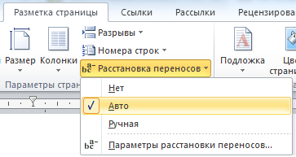

*Figure 1. Hyphenation*

**ALL** formulas, both inside the text and on separate lines, should **ONLY** be created using Equation or MathType with default settings (Fig. 2, 3).

Variables can be denoted with Greek or Latin letters. Latin letters (upper and lower case) should be in italics ( ). Greek lowercase letters should be in italics (), and Greek uppercase letters should be in normal font (). Vectors and matrices should be in bold ( ).

The width of each formula should not exceed 82.5 mm (equal to the column width in the journal).

***1.3.1. Hyphens in formulas.***

***How to break formulas.***

If a formula is too long for one line, it can be continued on the next line. Separation should preferably be made after a ratio symbol less preferably after dot leaders (...), plus and minus signs (, , ), and least preferably after multiplication signs . Do not break formulas after division signs.

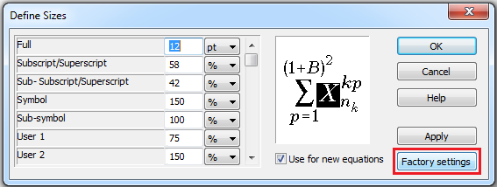

*Figure 2. Formula size settings*

Do not separate indices or exponents from their corresponding symbols. Do not separate expressions marked with an integral, logarithm, sum, or product sign from the sign itself.

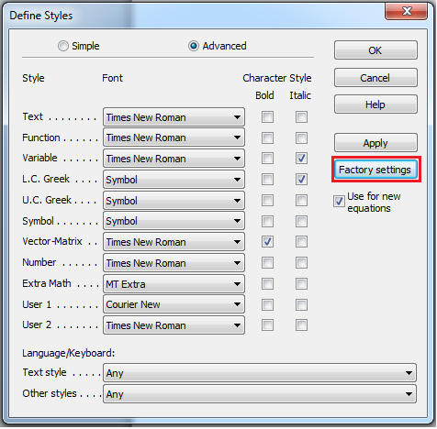

*Figure 3. Formua formatting settings*

The sign after which you break the formula shall be at the end of the first line and copied to the beginning of the second line of the formula. Dot leaders are also copied to the next line.

***Division of fractions with long numerators and short denominators***

We suggest converting the fraction to a decimal: the numerator is then a polynomial in brackets, and the reciprocal of the denominator is outside the parenthesis.

Fractions can only be divided after a plus (or minus) sign.

***Division of fractions with short numerators and long denominators***

We suggest using a forward slash instead of a division sign, and present the nominator and the denominator as polynomials in brackets. Certain elements of the denominator can be replaced with symbols explained after the formula.

***Division of formulas with long radical expressions***

Such expressions can be simplified by raising them to a corresponding power.

Radicals are separated after a plus sign.

See the example below.

**Vieta's theorem.** *The sum of the roots of a normalised quadratic equation*

 (1)

*is equal to the negation of the coefficient of the second term, and the product of the roots is equal to the intercept term.*



**Theorem proof.** Let’s consider ...

The equalities demonstrating the dependencies between the roots   and the coefficients of the quadratic equation  :



are called *Vieta’s formulas*.

**3. THEOREMS, LEMMAS, and DEFINITIONS.**

The words **Theorem**, **Lemma**, **Proof**, and **Definition** should be in bold. The statements of theorems and lemmas should be in *italics*. All definitions should be in normal font.

**3. FIGURES**

All Figures should be of good quality. They should be both in the text and submitted as separate *.png, *.jpg, or *.tif. files.

The size of the figures should be 82.5 mm (column width), 170 mm (printed page width), or 128 mm (2/3 of the page width).

Table 1

*Measurement units*

|  |  |
| --- | --- |
| Unit | Symbol |
| Length | m |
| Kilogram | kg |
| Second | s |
| Minute | min |
| Hour | h |

Figure captions should not be parts of the figures.

The font size in the figures should be 11 or 12 pt.

References to the figures in the text should be in the following format: Fig. 1. The figure should go after the first reference to it. In the final page layout figures may be shifted onto the following page. Therefore, please, avoid giving references to figures using the phrase “The following figure shows a graph...”. We recommend using phrases like “Fig.1 shows a graph...”.

Table 2

*Measurement units*

|  |  |  |  |
| --- | --- | --- | --- |
| Length | m | Minute | min |
| Kilogram | kg | Hour | h |
| Second | s |  |  |

**4. TABLES**

The size of the tables should be 82.5 mm (column width) or 170 mm (printed page width).

The font size in the tables should be 11 or 12 pt.

References to the figures in the text should be in the following format: Table 1. The table should be placed after the first reference to it. In the final page layout tables may be shifted onto the following page. Therefore, please avoid giving references to tables using the phrase “The following table shows the results of...”. We recommend using phrases like “Table 1 shows the results of...”.

Examples of table formatting: column width (Table 1), printed page width (Table 2).

**CONCLUSIONS**

The section presents the key results of the study.

**REFERENCES**

References in the text should be in the following format: [1], [1, 2], [3–5], [1, 6–8].

I. Books

***The book has one or more authors***:

(a monograph in Russian that does not have a parallel English name)

1. Kalashnikov, G. O. (2007) Sliyanie i pogloshchenie kompanii po pravu Evropeiskogo soyuza [Mergers and Acquisitions of Companies according to European Union Law]. Moscow, Mezhdunarodnye otnosheniya publ. (in Russian)

2. Abashidze, A. Kh. & Koneva, A. E. (2015) Dogovornye organy po pravam cheloveka [The Human Rights of Treaty Bodies]. Moscow, PFUR publ. (in Russian)

A monograph in English

3. Gray, C. (2012) The philosophy of law. New York, Routledge. Merryman, J. & Pérez Perdomo, R. (2007) The civil law tradition. Stanford, Calif, Stanford Univ. Press.

**The book only has an editor (no authors)**

4. Nersesyants V. S. (ed.) (2004) Problemy obshchei teorii prava i gosudarstva [Problems of the General Theory of Law and the State]. Moscow, Norma. (in Russian)

II. Journal articles

Both the paper and the journal have a parallel English name

5. Vasil'ev, V. I. (2015) Local Self Government on the Way to Centralization and Reduction of Electivity. Journal of Russian Law. (9), 149–161. (in Russian)

Neither the paper, nor the journal has a parallel English name

6. Krasovskii, A. A. (1914) K reforme nashego grazhdanskogo protsessa [To the Reform of Russian Civil Process]. Vestnik grazhdanskogo prava. (1), 27–66. (in Russian)

*A paper in German in a German-language journal*

7. Janzen, G., & Hawlik, M. (2005) Orientierung im Raum: Befunde zu Entscheidungspunkten. Zeitschrift für Psychologie. 213 (4), 179–186. (in German)

A paper in English in an English-language journal

8. Norcross, F. (1910) Criminal Law Reform. Journal of the American Institute of Criminal Law and Criminology. 1 (3), 386–393.

**The journal has only an issue number:**

9. Vasil'ev, V. I. (2015) Local Self Government on the Way to Centralization and Reduction of Electivity. Journal of Russian Law. (9), 149–161. (in Russian)

**The journal article** **has a** **DOI**

10. Lamond, G. (2014) Analogical Reasoning in the Common Law. Oxford Journal of Legal Studies. 34 (3), 567–588. Available from: doi:10.1093/ojls/gqu014.

**Publication in an online journal**

11. Winkel, L. (2010) Forms of Imposed Protection in Legal History, Especially in Roman Law. Erasmus Law Review. 3 (2), 155–162. Available at: http://hdl.handle.net/1765/21274 [Accessed 20th January 2017].

III. ***Chapter in an edited book*:**

12. Randall, L. (2012) Peace Treaties and the Formation of International Law. In: Fassbender, B., Peters, A. & Peter, S. (eds.) The Oxford handbook of the history of international law. Oxford, United Kindom, Oxford University Press, pp. 71–94.

**Translated books:**

13. Fuller, L. (1965) Moral' prava [The Morality of Law]. Translated from English by Danilova, T. (2016) Moscow, IRISEN. (In Russian)

14. Ehrlich, E. (1913) Osnovopolozhenie sotsiologii prava [Grundlegung der Sociologie des Rechts]. Translated from German by Antonov, M.V. (2011) Saint Petersburg, Universitetskii izdatel'skii konsortsium. (in Russian)

IV. Conference proceedings

15. Chirkin, V. E. (2017) Personal, Private and Public Interests in Modern Constitutions *In: Nemytina, M. V. (ed.) Interests in Law. Zhidkov’s readings: Procedings of All-Russian Scientific Conference, 25–26 March 2016, Moscow, Russia. Moscow, RUDN, pp. 177–183.* (in Russian)

**Anton A. Antonov –** DSc in Physics and Mathematics, Professor, Department of …, Voronezh State University.

E-mail: xxx@gmail.com

**Ivan I. Ivanov –** DSc in Physics and Mathematics, Professor, Department of …, Voronezh State University.

E-mail: xxx@gmail.com

**Petr P. Petrov –** 2nd year master’s degree student, Department of…, Voronezh State University.

E-mail: zzz@gmail.com